- Going to sleep in the cold could have helped animals cope with the Great Extinction. But who did it help? Reptiles or dinosaurs?
A DINOSAUR QUIZ FOR EXPERTS!

- Do you think having short legs would help animals deal with more types of places, than long legs? Can you suggest why? Which animals had shorter legs? Reptiles or dinosaurs?

- Which animals needed more to eat? Reptiles or dinosaurs? Do you think this was an advantage when there was not much food about?
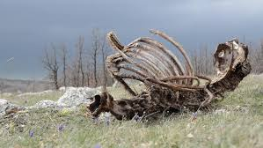
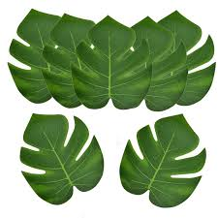

- Dinosaurs had a growth spurt early in their life. Do you think this was an advantage or a disadvantage after the Great Extinction? Why?

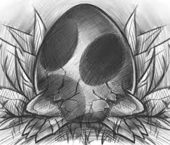
- Which eggs took longer to incubate, the eggs of reptiles or the eggs of dinosaurs? Why was this important after the Great Extinction?

- After the Great Extinction events, which animals do you think died out first, the herbivore dinosaurs? or the carnivore dinosaurs?

- Why do you think bird (avian) dinosaurs survived when the others did not?
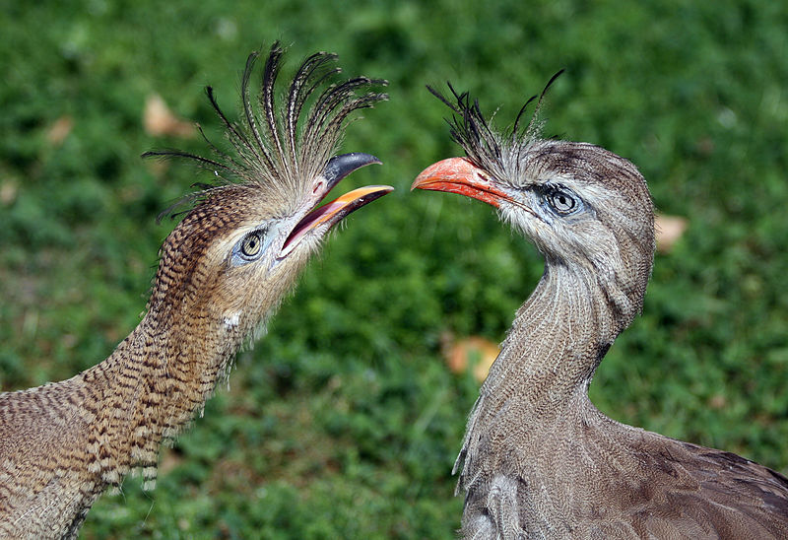

- What helped the bird (avian) dinosaurs keep warm when the other dinosaurs could not?

- Birds are (still) carnivores or omnivores. So why didn’t they die out like the other dinosaur carnivores?

- Birds are thought to have larger brains than the other dinosaurs. How do you think this helped them?

